
PERTH MODERN SCHOOL
UNIT 3CD MAS – 2015
TEST 1
POLAR COORDINATES, COMPLEX NUMBERS & VECTORS

NAME: DATE: Tues 17th Feb.
Total: 45 marks Time: 50 min.

Question 1 (5 marks)
(i) Point P has polar coordinates (4,17⁰) and it lies on the line 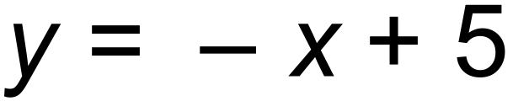
Point Q also lies on the line and is 12cm away from P.

Find the polar coordinates of Q 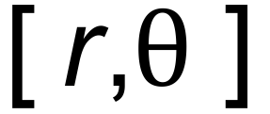 where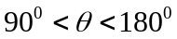. (3 marks)

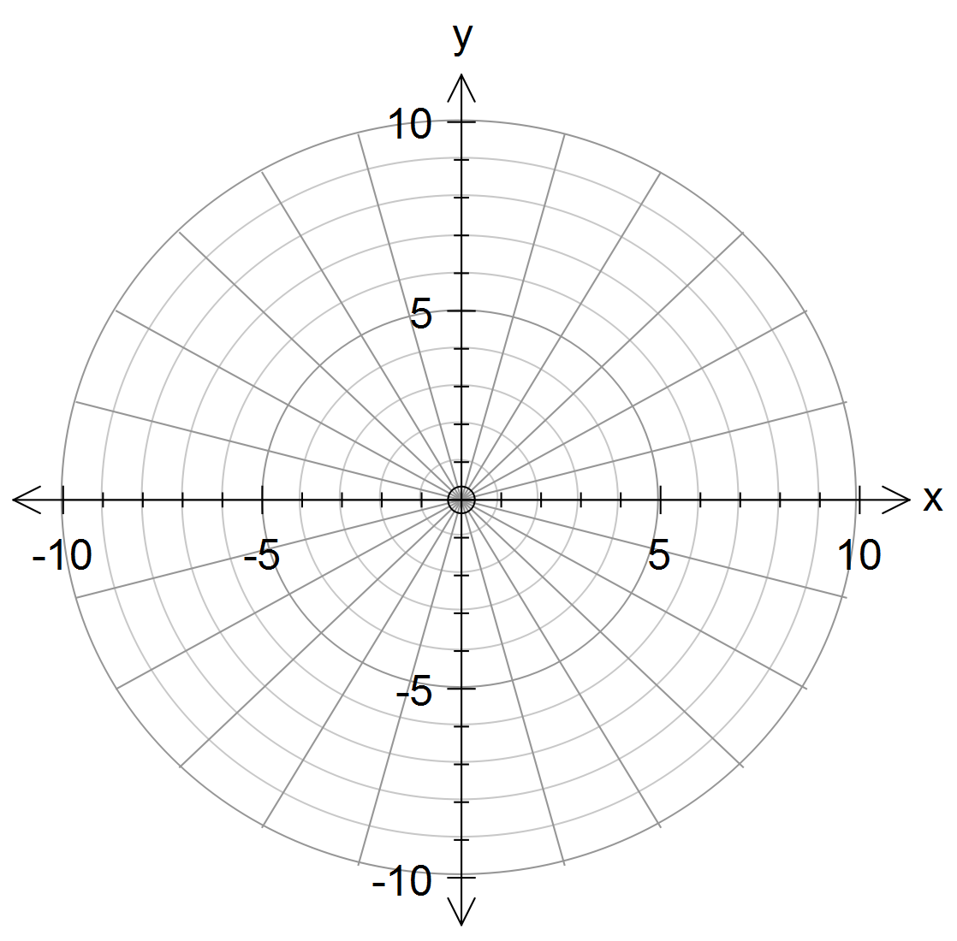

(ii) Sketch the graph of 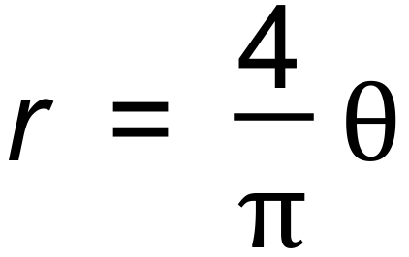 on the axes above and hence state
where it intersects 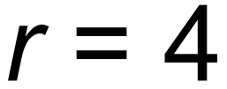 (2 marks)

Question 2 (9 marks)
On a 3D computer game, Chris, a keen cyclist leaves from position 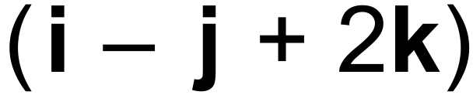 metres is travelling at 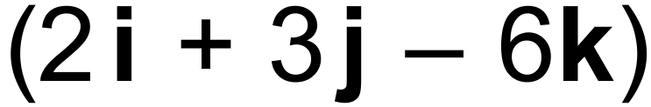 m/s while his mate Dave leaves from position 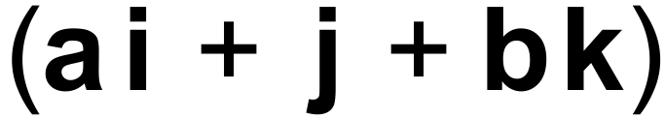 metres running at m/s.

(i) Although they do not collide, their paths do intersect at the point with coordinates
( a, 1, b).

Determine the values of a and b. (4 marks)

(ii) Find the acute angle between these two paths. (2 marks)

(iii) Hence, determine the perpendicular distance from the point (1,-1,2) to (3 marks)
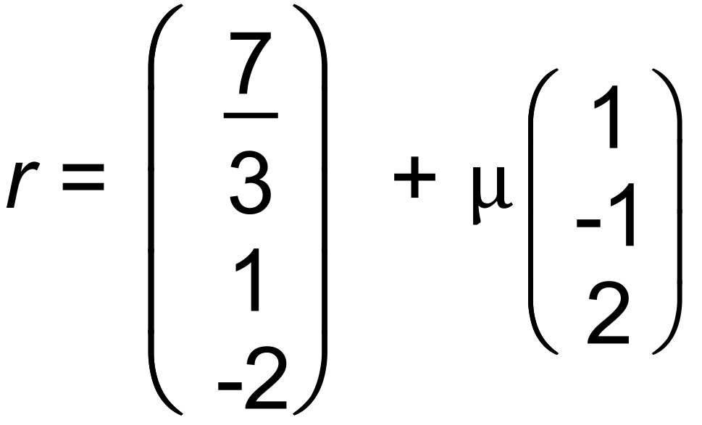

Question 3 (5 marks)
(a) The vectors 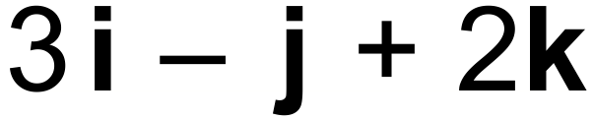 and  are perpendicular.

Determine the value of a.
(1marks)

(b) Determine whether the two lines

intersect. (4 marks)

If they do intersect, state the position vector of their point of intersection.

If they do not intersect, justify your answer.

Question 4 (7 marks)
(a) If 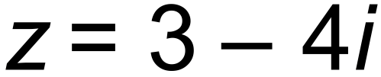 , determine the reciprocal,  (2 marks)

(b) Let the non-zero complex number  . Show that 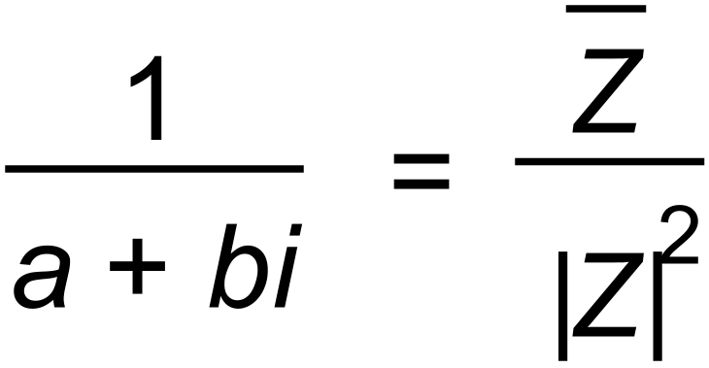 (3 marks)

(c) Describe the geometrical relationship between any non-zero complex number
and its reciprocal. (2marks)

Question 5 (5 marks)
denoted by the vectors, a, b, and c respectively, as shown in the diagram below.
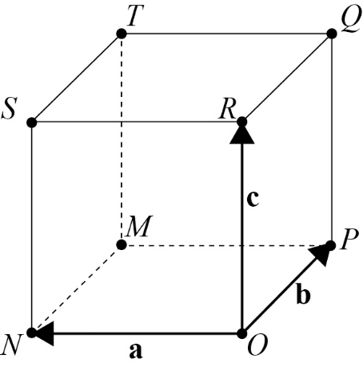

Suppose that A is the midpoint of 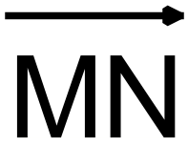 , B is the midpoint of 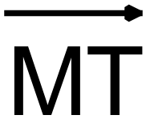 , C is the midpoint of 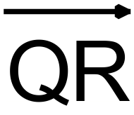
and D is the midpoint of 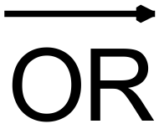.
(a) Express 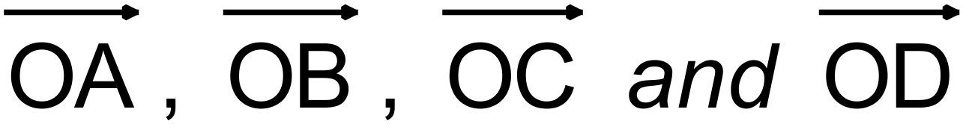 in terms of a, b, and c. (2marks)

(b) Prove that the quadrilateral ABCD is a parallelogram. (3 marks)

Question 6 (5 marks)
(a) Change the complex equation 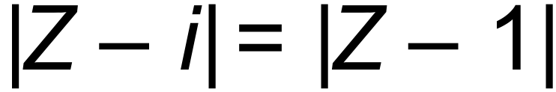 into its Cartesian equivalent. (3 marks)

(b) Hence identify, the locus of all points  satisfying the equation in (a). (2 marks)

Question 7 (5 marks)
An equilateral triangle has vertices A, B and C, where A is the point 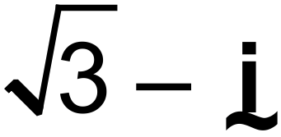 in the Argand plane.
The circumcircle is drawn that passes through vertices A, B, and C and has a centre inside the triangle called the circumcentre.
The circumcentre is located at the origin.
Find the complex numbers 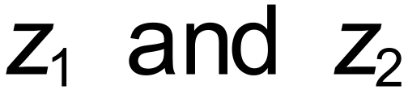 corresponding to the vertices B and C, expressing your answers in exact Cartesian form.

Question 8 (4 marks)
Find two numbers which have a product of 2 and a sum of 2.

